PAPER TITLE :-DATE:-

**Automatic Plant Watering System**

**Date -** March 2019

**JOURNAL/CONFERENCE:-** 2019 International Conference on Vision Towards Emerging Trends in Communication and Networking (ViTECoN).

**AUTHOR:-** Manisha Mayuree, Manisha Mayuree, Prof. Bagubali A.

**PROBLEM MENTIONED/SOLUTION OBTAINED:-**

**Problem Statement**

Many times, due to busy schedules, people forget to water their plants, which hinder their healthy growth. Also, it is very difficult for farmers to water their fields manually and to provide accurate amount of water for healthy growth of plants. Management of water also becomes a huge task due to water scarcity, since manual irrigation leads to wastage of water. Also, to avoid empty tank user should be notified to switch ON the motor to fill the tank.

**Solution**

Create a ARDUINO in such that it irrigates the plants based on the feedback of moisture content provided by the soil moisture sensor. When moisture content is lower than a prescribed limit, water pump starts irrigating. And When moisture content reaches the maximum limit, the water pump automatically switches off.

**ALGORITHM USED:-**

The prototype of an automatic plant watering system has been designed to cater to the irrigation needs of both small gardens and large crop fields. The core components of this system include an Arduino UNO microcontroller, a soil moisture sensor, a water level sensor, a water pump, and a GSM module. The system is programmed using the ARDUINO IDE software to monitor and respond to soil moisture levels. When the moisture content falls below a predefined threshold, the water pump is activated to initiate irrigation, with the flexibility to use either a sprinkler or a drip system. As the soil's moisture content reaches the desired level, the water pump is automatically turned off. Furthermore, the system ensures user engagement and convenience by sending notifications when water levels in the tank are low, prompting the user to initiate a refill. It also alerts the user to prevent tank overflow, signaling the need to switch off the motor. These notifications not only serve as practical reminders but also provide the user with crucial information regarding temperature and moisture levels, ensuring efficient and timely plant care.

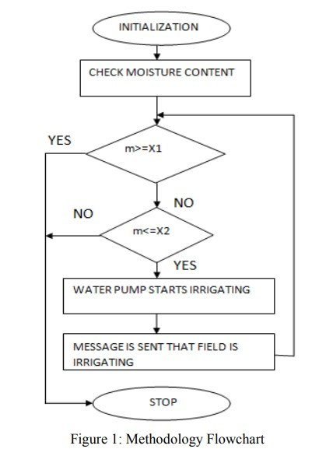

**TOOLS USED/IMPLEMENTED:-**

1. ARDUINO UNO
2. SOIL MOISTURE SENSOR
3. WATER LEVEL SENSOR
4. GSM MODULE
5. MOTOR SHIELD

**RESULTS AND DISCUSSION:-**

This is a low budget project which the farmers of the country can easily afford and can be further improved using technology. This project solves the problem of manual watering and saves a lot of time user. It also focuses on conserving water with increased accuracy in water distribution to the crops and energy. This project includes monitoring soil moisture and supplying water uniformly to the plants using sprinkler or drip system. It also keeps the track of water level.

**KNOWLEDGE AQUIRED:-**

* How can solar panels use to conserve energy.
* How feedback can be used to irrigates the plants.
* Based on the measuring of the soil moisture content can saves Farmer time.
* Avoid wastage of water in field.

**IMPORTANT REFERENCE:-**

1. G Alex, Dr.M. Janakiranimathi, “Solar Based Plant Irrigation System”, IEEE, Chennai, Tamil Nadu, 2016.
2. DrashtiDivani, Pallavi Patil, Prof. Sunil K. Punjabi, “Automated Plant Watering System”, IEEE, Navi Mumbai, India, 2016.
3. Tasneem Khan Shifa,“Moisture Sensing Automatic Plant Watering System Using Arduino Uno”,AJER, Bangladesh,2018.
4. K KNamala, Krishna Kanth Prabhu A V, Anushree Math, Ashwini Kumari, SuprajaKulkarni,“Smart Irrigation with Embedded System”, IEEE, Kalaburagi, India,2016.
5. BezaNegashGetu, Hussain A. Attia, “Automatic Control of Agricultural Pumps Based on Soil Moisture Sensing”, IEEE, Ras Al Khaimah, UAE, 2015.